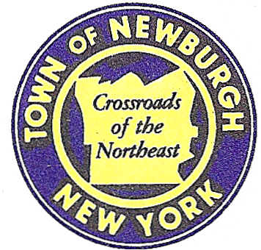

TOWN OF NEWBURGH
_______Crossroads of the Northeast __________________________
OLD TOWN HALL
308 GARDNERTOWN ROAD NEWBURGH, NEW YORK 12550

PLANNING BOARD
JOHN P. EWASUTYN, CHAIRMAN
TELEPHONE 845-564-7804
FAX 845-564-7802
E-MAIL: planningboard@townofnewburgh.org

PLANNING BOARD AGENDA

December 15th, 2016

*PLEASE NOTE: The Planning Board Meeting will start at 7:00 P.M. and all Applicants/Representatives
are to be present at that time. The Meeting will be held in the Meeting Room of Town Hall,
located at 1496 Route 300, Newburgh NY.*

1. Cumberland Farms (16-05) SITE PLAN
270 Route 17K LOT CONSOLIDATION
Section 86, Block 1, Lot 14 & 15
Zone: IB
Rep: Bohler Engineering
17 Computer Drive West, Suite 203
Albany, NY 12205

2. RAM Hotels (16-21) INITIAL APPEARANCE
Unity Place 2 LOT SUBDIVISION
Section 97, Block 2, Lot 37 SITE PLAN
Zone: IB
Rep: Mecurio-Norton-Tarolli- Marshall
45 Main St. PO Box 166
Pine Bush, NY 12566

3. Brophy Lot Line Change (16-22) INITIAL APPEARANCE
River Road and Anchor Drive LOT LINE CHANGE
Section 4, Block 3, Lot 58.3 &
part of Anchor Drive R.O.W Section 121, Block 1, Lot 22
Zone: R-1
Rep: Talcott Engineering Design, PLLC
1 Gardnertown Road
Newburgh, NY 12550
*WORK SESSION*
Project Readiness Discussion scheduled for 5:30 p.m. in the Meeting Room of
Town Hall on Thursday, December 15th, 2016.*

PLANNING BOARD BUSINESS
WORK SESSION

1. Lands of Zazon (04-29) 6 month extension December 15, 2016 to June 15, 2017.

*WORK SESSION*
Project Readiness Discussion scheduled for 5:30 p.m. in the Meeting Room of
Town Hall on Thursday, December 15th, 2016.*

